A picture containing clipart

Description generated with very high confidence

Hands-on

Creating Organizational Units

AWS Solutions Architect

[**support@intellipaat.com**](mailto:support@intellipaat.com)

**+91-7022374614**

**US: 1-800-216-8930(Toll Free)**

**Creating Organizational Units**

**Step 1:** Go to AWS Organizations. Then go to Organize accounts and click on Organizational Unit.

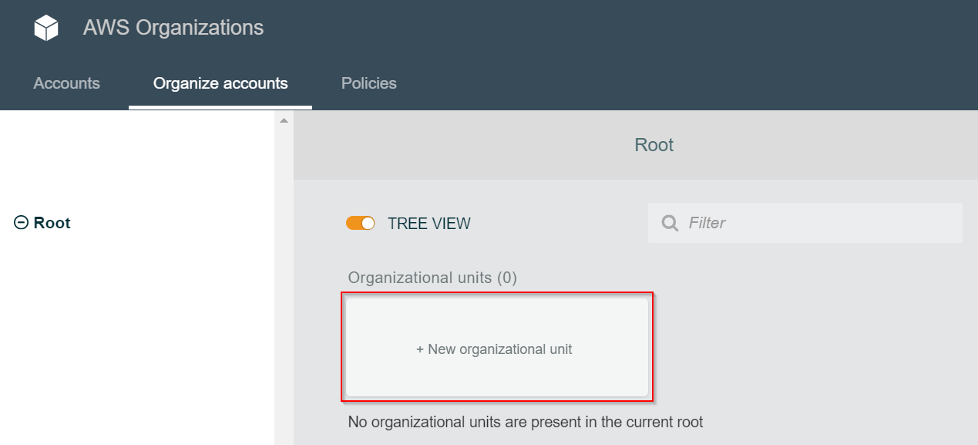

**Step 2:** Give the name of your organizational unit and click on the button

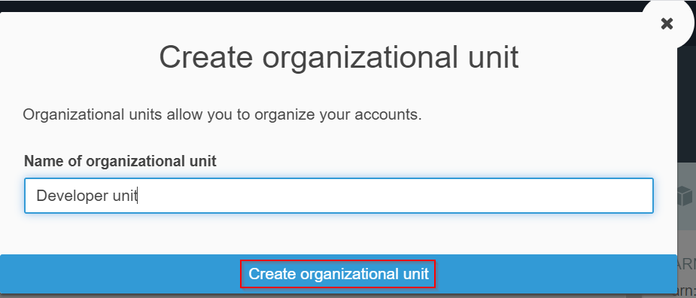

**Step 3:** Check out the dashboard to see the organizational unit (OU) ‘ Developer unit’ which was just created

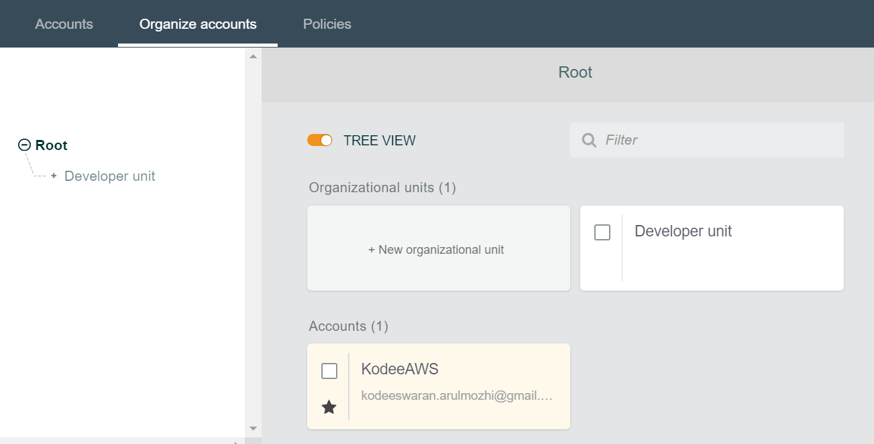

**Step 4:** Under the created OU, create 2 more OUs in the name of Web and mobile. If you have added any account other than the master account, click on it and move it to a OU.

